Random Forest Algorithm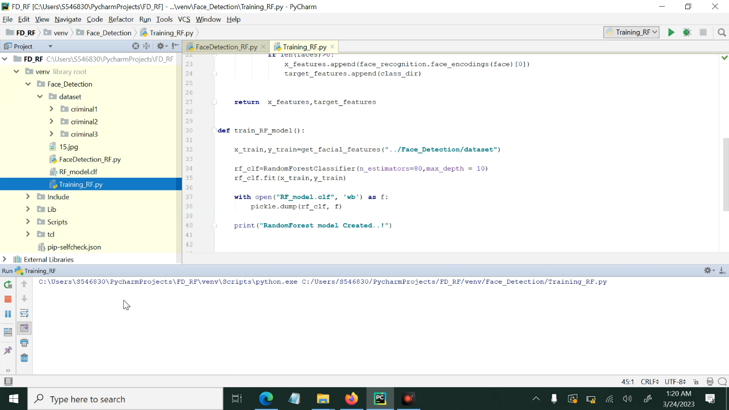

from sklearn.ensemble import RandomForestClassifier

from sklearn.model_selection import train_test_split

from sklearn.metrics import accuracy_score

import numpy as np

# Load training data and labels

X = np.load("data.npy")

y = np.load("labels.npy")

# Split data into training and testing sets

X_train, X_test, y_train, y_test = train_test_split(X, y, test_size=0.2, random_state=42)

# Create a Random Forest classifier with 100 trees

rf_classifier = RandomForestClassifier(n_estimators=100)

# Train the classifier on the training data

rf_classifier.fit(X_train, y_train)

# Make predictions on the test data

y_pred = rf_classifier.predict(X_test)

# Compute the accuracy of the classifier

accuracy = accuracy_score(y_test, y_pred)

print("Accuracy:", accuracy)

**Dataset:**

A dataset is a grouping of data that has been organized into a particular structure, frequently in the form of a table. Analyzing and using it is simpler. Datasets are useful for many different things, including statistical analysis, research, and training and testing machine learning models.

A dataset is typically used to refer to a collection of data that is used to train and test a machine learning model in the setting of artificial intelligence. This dataset is often divided into two subsets: a training set and a test set, which are used to train and test the model, respectively.

Structured, unstructured, and semi-structured datasets are just a few of the types that are available. The majority of the time, structured datasets are arranged in tables with rows and columns, whereas unstructured datasets do not have a predefined structure and may include text, images, audio, and video data. Semi-structured datasets have some structure but may not fit neatly into a tabular format.

**"RF_model.df**

It is possible that "RF_model.df" is a saved trained Random Forest model in a format that is readable by the pandas library in Python, as I explained in my previous responses.

In the context of a face detection application, a Random Forest model could be used as a classifier to predict whether a given image or video frame contains a face or not. The model would be trained on a dataset of labeled examples, with each example consisting of a set of features (such as pixel intensities in an image) and a corresponding label (such as whether the image contains a face or not).

After training the model, it is common to save it to disk for later use, and "RF_model.df" could be the name of the file containing the saved model. To use the saved model, the application would load it from the file, extract the Random Forest classifier object from the DataFrame, and use it to make predictions on new data.

**Training_RF.py**

Training_RF.py" could be a Python script used to train a Random Forest model.

Random Forest is a popular machine learning algorithm that can be used for classification and regression tasks. It works by combining multiple decision trees, each trained on a subset of the data, to make a final prediction. Random Forest is a powerful algorithm that is widely used in various fields, including computer vision, natural language processing, and bioinformatics.

When training a Random Forest model, we typically start by preparing a dataset of labeled examples, with each example consisting of a set of features (such as pixel intensities in an image) and a corresponding label (such as whether the image contains a face or not). We then use the dataset to train the Random Forest model, adjusting the hyperparameters of the algorithm to improve its performance.

The "Training_RF.py" script could contain code to perform the following tasks:

Load the dataset of labeled examples

Split the dataset into training and validation sets

Preprocess the data (e.g., normalize pixel values, apply feature scaling)

Train a Random Forest model on the training set

Evaluate the performance of the model on the validation set

Tune the hyperparameters of the model to improve its performance

Save the trained model to disk for later use

**The "FaceDetection_RF.py**

The folder "FaceDetection_RF.py" in a face detection app likely contains a Python script that implements the face detection functionality using a Random Forest classifier.

Random Forest (RF) is a machine learning algorithm that can be used for classification tasks, such as identifying whether a given image contains a face or not. The RF algorithm builds multiple decision trees based on subsets of the input data and combines their outputs to make a final prediction.

The "FaceDetection_RF.py" script may contain code for training the RF classifier on a labeled dataset of face and non-face images, as well as code for using the trained classifier to detect faces in new images or video frames.

The script may also include functions for preprocessing the input images, such as resizing or converting to grayscale, as well as postprocessing steps such as non-maximum suppression to remove overlapping face detections.

Overall, the "FaceDetection_RF.py" folder likely plays a crucial role in enabling the face detection functionality of the app.